DHR Diesel NDM6 Loco brass body Kit in 16mm scale
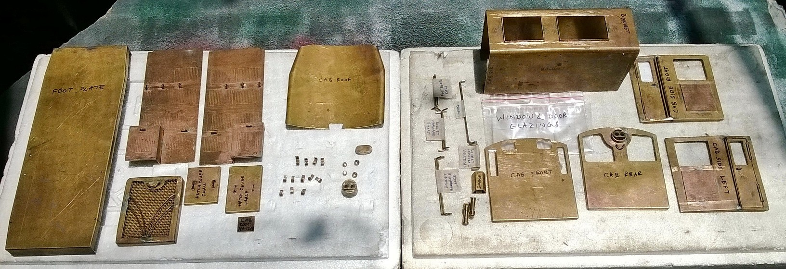
Item Code: KNDM6
Scale: 16mm=1foot
Set: 1 complete body kit
Dimensions: L=283mm (cab rear to radiator end); H=92mm (footboard top to roof top); W=110mm (cab roof ends).
Description: Complete brass kit to build the DHR Diesel NDM6 loco in 16mm scale, as used in our RTR NDM6 in the same scale. All necessary prefabricated, cast and machined brass parts to build the body shell are included. Required holes are factory drilled, threads tapped, corners filed, and folds formed. Needs very little filling and finishing. Just needs small hand tool and soft soldering equipment, etch primer, paints, decals and etc to build. Builder can build his own chassis & buffer beams or use our standard RTR NDM6 chassis & buffer beams (optional extra).
Kit Includes:
Pre-fabricated sheet metal parts: Foot plate X 1 off
Bonnet X 1 off
Radiator X 1 off
Cab front X 1 off
Cab rear X 1 off
Cab sides with pre-soldered doors X 2 off
Cab roof with X 2 off
Hatch covers X 2 off
Sand boxes X 4 off
Fuel tanks X 2 off
Smoke Stack X 1 off
Bonnet side boxes X 2 off

Cast & Machined parts: Front head light X 1 off
Rear Head light X 1 off
Air horns with 8BA brass screws X 2 off
Air horn mount X 1 off
Sand box filler caps X 2 off
Fuel tank filler caps X 2 off
Radiator filler cap X 1 off
Cleats X 12 off
Cab handrails X 4 off
Bonnet long handrail X 2 off
Bonnet short handrail X 2 off
Bonnet Vertical handrails X 2 off
Radiator handrail X 1 off
Cab rear handrail X 1 off
Hatch handrails X 4 off
Bonnet side steps X 6 off
Lock handlebars X 8 off
Footplate handrails X 2 off

Brass Photo-etched parts: Complete bonnet side overlays X 2 off
Bonnet box side louvers X 2 off
Cab side louvers X 2 off
Door side louvers X 2 off
Number & makers plates X 2 off

Others: Pre-cut and shaped window glazing X 8 off
Detailed assembly instructions/drawings sheet X 1 off

Required: A suitable power bogie and a pair of suitable buffer beams with DHR style ‘D’ couplers.
Or our standard NDM6 buffer beams with marker/fog lights and DHR style ‘D’ couplers and NDM6 RTR power bogie with 2 motors & all metal drives, all in 16mm scale (optional extra).

Small hand tools like nose pliers, small hammer, centre punches, a set of jewelers files, small snips, 1.6mm drill bit & hand drill, 8BA tap & handle, small vice, pincers, soft soldering equipment, 60/40 soft solder, suitable flux, engineers squares, slide calipers, safety goggles & gloves, etch primer, masking tape, aerosol primer & paints, 100 grit emery paper, all necessary electrical (DPDT switches, fuse holder & fuse, charging socket, wires, connectors),suitable battery pack, RC set, ESC, sound card and etc.

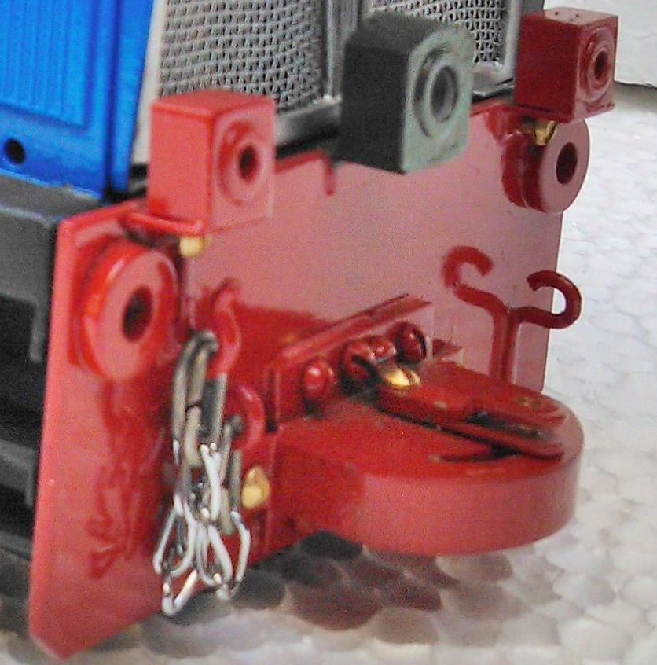

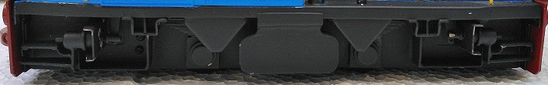

Our Standard 16mm scale NDM6 buffer beams & RTR Power bogie as optional extras.

